SECTION ONE—MULTIPLE CHOICE
This section has 10 questions. Answer all questions on the separate Multiple-choice Answer Sheet provided.

- Which of the following is NOT a disease related to poor nutrition?
- Asthma
- Obesity
- Cardiovascular Disease
- Diabetes

- Digestion begins in the mouth. Which of the following statement is incorrect?
- The tongue aids in the digestion of the food.
- The saliva changes some of the starches in the food to sugar.
- The tongue keeps the food in place in the mouth while the food is being chewed.
- The digestive juices in mouth are produced from tongue.

- Which of the following is not an example of the functioning of the mouth?
- salivary amylase breaking down starch to simple sugars
- peristalsis
- chewing food to break into smaller pieces
- formation of a bolus

- Most of the nutrient absorption that takes place during digestion occurs in the:
- Liver
- Large intestine
- Small intestine
- Stomach

- The kidneys and urethra are part of what organ system?
- Respiratory
- Digestive
- Urinary
- Reproductive

- The renal vein transports blood –
- into the kidney
- into the ureter
- out of the ureter
- out of the kidney.

- If a large amount of water is drunk, it will –
- produce a greater volume of urine
- have no effect on the amount of urine produced
- produce very concentrated urine
- produce a greater volume of urine that is dark yellow.

- Which of the following organs functions to absorb water, salts, and store non-digestible material?
- Stomach.
- Small intestine.
- Large intestine.
- Liver

- Which of the following statements are not true regarding kidneys?
- They do not have any capsule.
- They are bean shaped and reddish in colour.
- Each kidney is divided into 2 parts – cortex and medulla.
- They are the main excretory organs.

- Which answer below shows the correct order of the structures through which urine would travel through during urine formation and excretion?
- nephron, renal pelvis, urethra, bladder, ureter
- nephron, renal pelvis, ureter, bladder, urethra
- renal pelvis, ureter, nephron, urethra, bladder
- renal pelvis, nephron, ureter, bladder, urethra

END OF MULITPLE CHOICE
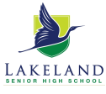
TASK 7: TEST
HUMAN BIOLOGY GENERAL YEAR 11
ANSWER BOOKLET

NAME:

CLASS: DATE:

Multiple Choice Short Answer Total

/10
/15

/ 40

/ 55

/30

/35

Time allowed –Working time for paper 55 minutes

Instructions to candidates
Answer the multiple-choice questions on the answer sheet provided.
Write your answers to the short answer section in the spaces provided beneath each question
Answers that require a numerical answer should show all working out in logical steps.
Candidates should write clearly with a pen unless otherwise directed

SECTION ONE: Multiple choice answers
Cross (X) through the correct answer.

1 | a | b | c | d
2 | a | b | c | d
3 | a | b | c | d
4 | a | b | c | d
5 | a | b | c | d
6 | a | b | c | d
7 | a | b | c | d
8 | a | b | c | d
9 | a | b | c | d
10 | A | b | c | d

PART B: SHORT ANSWER SECTION
- Outline the processes of mechanical and chemical digestion including the general parts of the digestive system involved. (2 marks)
____________________________________________________________________________________________________________________________________________________________________________________________
__________________________________________________________________________________________________________________________________________________________________________________________
- List two functions of the kidneys. (2 marks)
_________________________________________________________________________________________________________________________________________________________________________________________________________________________________________________________________________________________
- Give the functions of the following parts of the urinary system. (4 marks)
- Renal artery ______________________________________________________________
________________________________________________________________________
- Ureter ___________________________________________________________________
________________________________________________________________________
- Urethra__________________________________________________________________
________________________________________________________________________
- Bladder _________________________________________________________________
________________________________________________________________________

- Label the following structures of the kidney. (4 marks)
- ___________________________
- ___________________________
- ___________________________
- ___________________________

- The following questions refer to the diagram below showing
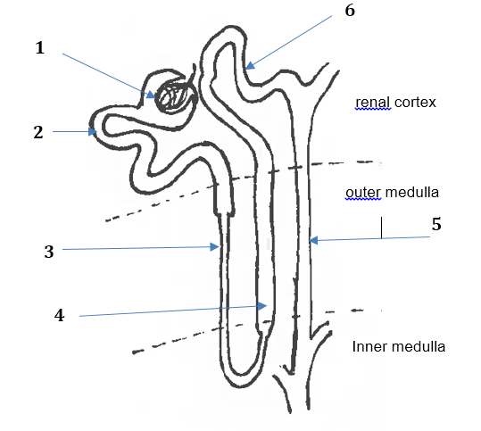 Figure 1 Kidney nephron
Match each of the processes (identified on the diagram with numbers 1 – 7) to the correct description of the process. Write the process number next to the correct description in the first column. Identify one substance passing through during this process in the last column where substances passing through are not given. (5 marks)

Process number | Description of the process | Substances passing through
1 |  | Glucose, Water Ions
 | Active secretion of ions in the distal convoluted tubule
 | Active transport of salt from the ascending limb of the loop of Henle.
3 |  | Water
6 |  | water

- Amylase is an enzyme that breaks starch down into glucose or sugars. An experiment was performed to determine the effect of temperature on amylase activity. The data collected is shown in the table. Starch was put into test tubes and amylase was added to the test tubes. The test tubes were then placed in a water bath at the different temperatures (4 marks)

- State the independent variable. _________________________________________________

- State the dependent variable. ___________________________________________________

- State at least 2 controlled variables. ______________________________________________
______________________________________________________________________________________________________________________________________________________

- What hypothesis could the scientist have been testing? (2 marks)
_________________________________________________________________________________________________________________________________________________________________________________________________________________________________

The results of the amylase experiment are presented in the following table.

Temperature (°C) | Rate of Sugar Production (g/min)
5 | 1
10 | 10
20 | 35
30 | 60
50 | 20
60 | 4
70 | 0

- Graph the results on the paper provided. (5 marks)


- What do the results show about the temperature and the rate of sugar production?
(2 marks)
______________________________________________________________________________________________________________________________________________________________________________________________________________________________

- What can the scientist do to make the investigation more reliable? (1 mark)
____________________________________________________________________________________________________________________________________________________

END OF TEST

